Camera MFD

## Features

* Supports both Orbiter 2016 and Orbiter 2010.
* Unlimited highly customizable cameras, directly controlled from the MFD.
* Configuration files to define cameras for vessels and each scenario.
* An API which allows vessels to control the MFD through the source code.

## Installation & Setup

Unpack the archive directly into the Orbiter folder. The D3D9 client must be installed and activated for the MFD to work. The MFD doesn’t work with the Orbiter stock rendering engine.

The custom cameras option in the D3D9 client must be activated. To activate it, open the ‘Video’ tab in the launchpad, click on the ‘Advanced’ button.

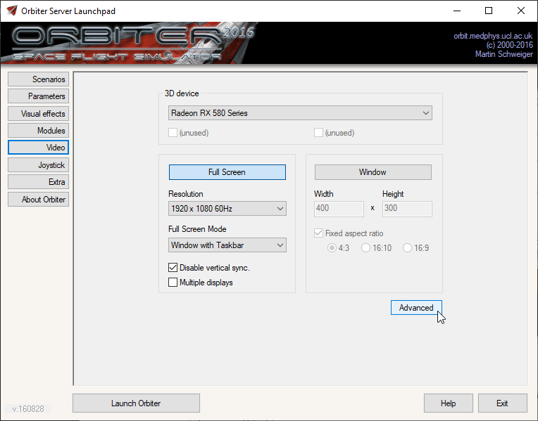

In the ‘Reflections and Custom camera settings’ section, set ‘Custom Cameras’ to ‘Enabled’, and click on the ‘Ok’ button.

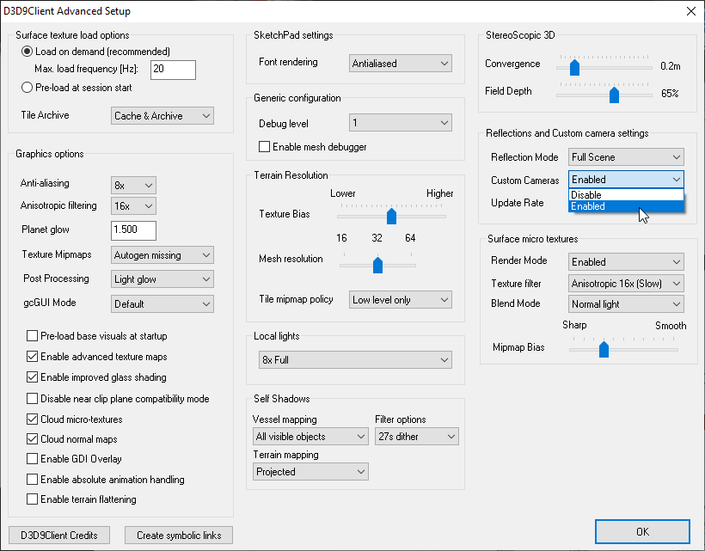

Then enable the MFD in the ‘Modules’ tab in the launchpad, under the ‘MFD modes’ section.

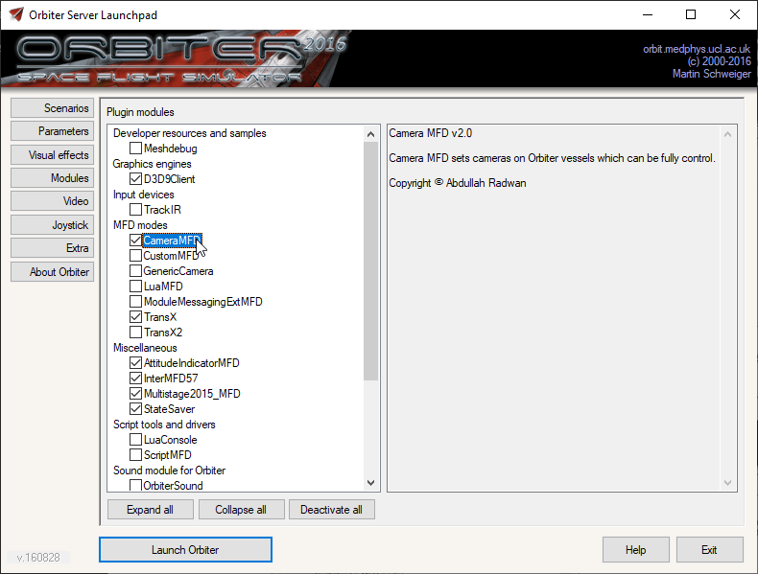

## Usage

When you first open the MFD, you will notice 2 sets of buttons: one on the left, and one on the right.

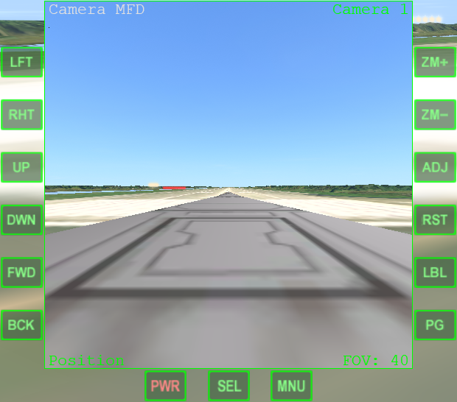

The left buttons are used to control the camera in the current adjust mode. There are 3 adjust modes: position, direction, and rotation. The current mode is shown at the bottom left.

In the position mode, you can adjust the camera position on the vessel using the buttons on the MFD.

In the direction mode, you can adjust the camera direction (where the camera faces).

In the rotation mode, you can adjust the camera rotation (so you can make the camera picture upside down for example).

The right buttons are used to control different MFD functions. There are 2 pages. You can change the page with the ‘PG’ button.

On the first page, you can adjust the camera field of view (ZM+ and ZM-), change the adjust mode (ADJ), reset the current adjust mode to the default values (RST), and change the camera label (LBL). The label can’t be empty, and it must be 20 letters or less.

The maximum FOV is 80 degrees, and the minimum is 0.5 degrees.

On the second page, you can switch between the currently defined cameras (CM+ and CM-), add a new camera (ADD), delete the current camera (DE), and change the camera information display mode (INF).

There are 3 information display modes: none, minimum, and full information.

The first mode will display no information on the MFD. The minimum mode will display the current camera name, current adjust mode, and the FOV only. The full mode will display the minimum mode information plus the current adjust mode data.

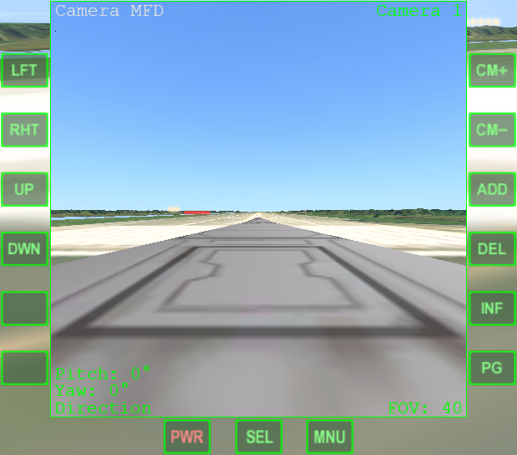

For vessels that control Camera MFD, the user control can be limited or eliminated. For example, the user may not be able to change the position or rotation of the camera (only the direction) or the camera FOV. In such cases, the buttons which control the restricted function will be inoperative. Regardless of the vessel settings, the user can’t change the camera label or delete/add cameras, only the vessel can.

If the vessel controls Camera MFD while allowing the user to change the position, direction, rotation, and/or FOV, the user inputs are separated from the vessel inputs.

When the vessel changes the camera data, the user inputs will be added to the new data (e.g. the vessel sets the rotation angle to 5 degrees, the user adds 5 degrees (the total 10). If the vessel sets the rotation angle to 10 degrees, the user 5 degrees will be added (so the total will be 15 degrees). This applies to position, direction, and FOV as well.

When resetting the camera, only the user inputs will be reset (so in the above example, when the user resets the rotation, the rotation angle will be set to 10 degrees).

The adjust mode data in the full camera information display mode are for the user inputs only.

Note: in Orbiter 2010, the vessel that created the camera can’t be seen, but you can see other vessels.

## Configuration Files

The configuration files can be used to define default cameras for each vessel or each scenario. The files are placed in the ‘Config\CameraMFD’ folder.

To define default cameras for a vessel class, create a file named after the vessel class name (i.e. the name of the vessel configuration file in the ‘Config\Vessels’ folder with the ‘cfg’ extension (e.g. ‘Deltaglider.cfg’ for Orbiter default DeltaGlider). The file will be loaded only if the scenario doesn’t have Camera MFD data in it (so the MFD wasn’t opened on that scenario before). The MFD comes with default cameras for Orbiter default DeltaGlider as an example. It’s ‘Config\CameraMFD\Deltaglider.cfg’.

To define cameras for a scenario, the file name can be any name with the ‘cfg’ extension.

The configuration file is used only for the first time. Once the scenario is opened, the cameras are no longer related to the configuration file. It will be saved in the scenario file.

Since the format used in the configuration file is the same format used to save the cameras in the scenario file, it’s recommended that you set the cameras you want in the MFD, then save the scenario and take the data from it into the configuration file.

To do so, open a scenario with the vessel you want to set the configuration file for and set the cameras as you want. Once you are finished, close Orbiter and open the ‘(Current state).scn’ file in the ‘Scenarios’ folder with a text editor, and search for Camera MFD data.

BEGIN_MFD

TYPE User

MODE Camera MFD

………………

END_MFD

Cut the data from CCAM 0 until CURCAM with the number after it and paste it in the configuration file. Remove the whitespaces before the text and the ‘U’ from CUPOS, CUPIT, CUYAW, and CUROT in every camera section (so it becomes CPOS, CPIT, CYAW, and CROT).

CCAM 0

CLBL Camera 1

CPOS -0.03 1.27 7.65

CPIT 0.00

CYAW 0.00

CROT 0.00

CFOV 40.00

CURCAM 0

Set CURCAM to the index of the camera you want the MFD to show when it’s first loaded (the index is the number after CCAM for the camera you want).

Save the configuration file. The steps are over for vessel default cameras.

If you want the configuration file to be specific to that scenario, open the scenario you want, open Camera MFD in the vessel you want, and close Orbiter. Open the current state scenario as stated and remove all lines between BEGIN_MFD and END_MFD (but don’t remove BEGIN_MFD and END_MFD). Insert the following lines instead and replace ‘DeltaGlider Scn Test’ with the configuration file name without the ‘cfg’ extension.

TYPE User

MODE Camera MFD

CCFG DeltaGlider Scn Test

## API

The API allows vessels to control the MFD by the source code. See the API document in the ‘Orbitersdk\doc’ folder.

## About

Camera MFD is free and open-source under the GPLv3 license. The source code can be found in the [GitHub repository](https://github.com/abdullah-radwan/CameraMFD). Special thanks to [Face](https://www.orbiter-forum.com/members/face.267/) for the camera control logic, and [Gattispilot](https://www.orbiter-forum.com/members/gattispilot.29/) for testing the MFD.

Copyright © Abdullah Radwan, [abbodmar@gmail.com](mailto:abbodmar@gmail.com)